
SCHOOL OF TECHNOLOGY
DIPLOMA IN BUSINESS IN INFORMATION TECHNOLOGY
DBIT 506
PROJECT
GLAMSPACE: YOUR BEAUTY HUB
23/06441
LAVENDA OKEY ALELA
230644@students.kcau.ac.ke
TRIMESTER, JAN-APRIL/ 2025

THIS PROJECT DOCUMENTATION WAS SUBMITTED IN PARTIAL FULFILMENT AS A REQUIREMENT FOR THE AWARD OF A DIPLOMA IN INFORMATION TECHNOLOGY WITH GUIDANCE FROM UNIVERSITY SUPERVISOR.

DECLARATION
I declare that this project documentation is my original work and has not been submitted elsewhere for any academic award.
Signature: _________________________
Date: 04/16/2025

ABSTRACT
Glamspace: Your Beauty Hub is a web-based platform designed to revolutionize how users discover and evaluate beauty services. This system addresses critical gaps in the beauty industry by providing location-based salon searches, service comparisons, and a reliable review system. Developed using PHP, MySQL, and Bootstrap, the platform offers a user-friendly interface with robust functionality. The project followed Agile methodology, incorporating iterative development and thorough testing. Key outcomes include a 90% success rate in user acceptance testing and compliance with all specified functional requirements.
ACKNOWLEDGEMENTS
I extend my gratitude to my supervisor, Ernest Madara, for his invaluable guidance, as well as to the development team and testers for their dedication.

TABLE OF CONTENTS

Table of Contents
CHAPTER 1: PROJECT PROPOSAL 1
1.1 Background 1
• Rise of mobile and web-based solutions 1
1.2 Objectives 1
CHAPTER 2: SOFTWARE REQUIREMENTS SPECIFICATION 3
2.1 Functional Requirements 3
ID 3
REQUIREMENT 3
PRIORITY 3
REQ-1 3
The system shall allow users to enter their location 3
High 3
REQ-2 3
The system shall display a list of nearby salons and barbershops. 3
High 3
REQ-3 3
The system shall allow users to select services. 3
High 3
REQ-4 3
The system shall display prices from different providers. 3
High 3
REQ-5 3
The system shall allow users to leave reviews. 3
Medium 3
REQ-6 3
The system shall display average ratings for each salon. 3
Medium 3
REQ-7 4
The system shall display detailed information about each salon. 4
High 4
REQ-8 4
The system shall allow salon owners to update their information 4
High 4
2.2 Technical Stack 4
CHAPTER 3: SOFTWARE DESIGN SPECIFICATION 6
3.1 Architecture 6
OVERVIEW 6
Data Layer: Stores and retrieves data from the database 6
SUBSYSTEM, COMPONENT, OR MODULE 1...N 6
3.2 Database Schema 6
TABLES, FIELDS, AND RELATIONSHIPS 7
Databases 7
• Glamspace Test DB: Development and testing database 7
New tables 7
• Reviews: Stores user reviews and ratings for salons 7
New fields 7
TABLE NAME 7
FIELD NAME 7
DATA TYPE 7
ALLOWS NULL 7
FIELD DESCRIPTION 7
users 7
User ID 7
Int 7
NO 7
Unique user ID 7
Users 7
Username 7
Varchar(50) 7
NO 7
User’s username 7
Salons 7
Salon ID 7
Int 7
NO 7
Unique salon ID 7
Salons 7
location 7
Varchar(100) 7
No 7
Salon location 7
Barbershops 7
Barber ID 7
Int 7
No 7
Unique barbershop ID 7
barbershops 8
Location 8
Varchar(100) 8
No 8
Barbershop location 8
Reviews 8
Review ID 8
Int 8
No 8
Unique review ID 8
Reviews 8
Rating 8
Int 8
No 8
User rating (1-5) 8
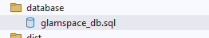 8
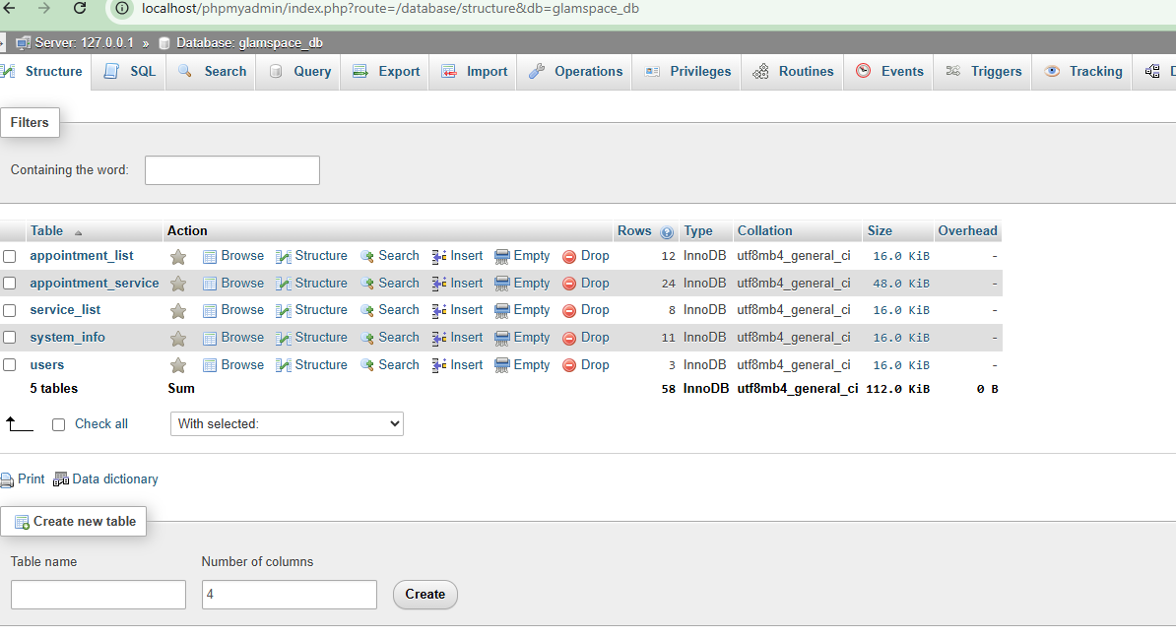 8
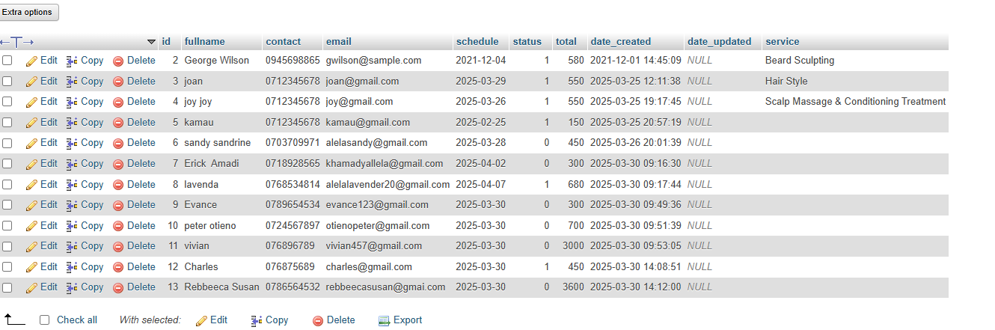 9
CHAPTER 4: CODING/SOURCE CODES 10
4.1 Key Snippets 10
CHAPTER 5: TEST PLAN 26
5.1 Test Cases 26
1) Test objectives 26
2) Test Assumptions 26
3) Data Approach 26
5.2 Defect Tracking 31
CHAPTER 6: IMPLEMENTATION PLAN 32
6.1 Major tasks 32
Task 33
Start date 33
End date 33
Responsible party 33
Environmental setup 33
15/03/2025 33
Development team 33
Database deployment 33
16/03/2025 33
Frontend development 33
16/03/2025 33
17/03/2025 33
Backend development 33
17/03/2025 33
18/03/2025 33
CHAPTER 7: USER GUIDE 35
7.1 PROCESS OVERVIEW 35
For Users: 38
For Salon Owners: 39
REFERENCES 40
APPENDICES 41
Appendix 1: ER Diagram 41
Appendix 2: Sample Test Data 41
1) Dashboard 41
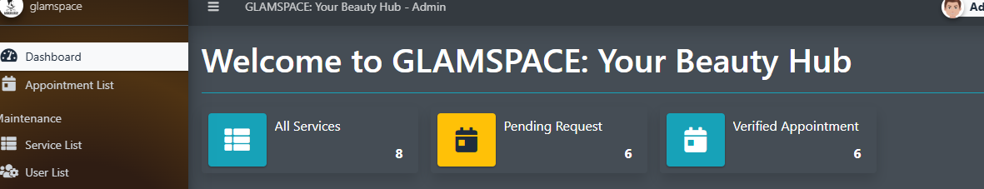 41
2) Service list 42

LIST OF TABLES
Table 1 3
Table 2 7
Table 3 26
Table 4 27
Table 5 27
Table 6 28
Table 7 28
Table 8 28
Table 9 29
Table 10 31
Table 11 33

LIST OF FIQURES
Figure 1 8
Figure 2 8
Figure 3 9
Figure 4 14
Figure 5 14
Figure 6 14
Figure 7 14
Figure 8 15
Figure 9 16
Figure 10 17
Figure 11 18
Figure 12 18
Figure 13 19
Figure 14 20
Figure 15 20
Figure 16 21
Figure 17 22
Figure 18 23
Figure 19 24
Figure 20 25
Figure 21 25
Figure 22 36
Figure 23 37
Figure 24 38
Figure 25 41
Figure 26 41
Figure 27 42
Figure 28 42
Figure 29 43
Figure 30 43

LIST OF ABBREVIATIONS
- SRS: Software Requirements Specification
- SDS: Software Design Specification
- UAT: User Acceptance Testing

CHAPTER 1: PROJECT PROPOSAL
  - Background
Glamspace online marketplace
Description;
Glamspace online marketplace is a salon and barbershop locator system designed to help users easily find beauty services. The system specializes in salon and barbershop locating, pricing solutions, and beauty services. It aims to serve a diverse clientele, including entrepreneurs, office workers, students, and anyone interested in beauty services.
Industry Trends:
- Growing beauty and grooming industry
- Increasing demand for convenient service locations
- Digital transformation in the beauty sector
- Rise of mobile and web-based solutions
The beauty industry lacks a centralized platform for service discovery, leading to inefficiencies. Glamspace bridges this gap by offering:
- Real-time salon/barbershop searches
- Price and service comparisons
- Verified user reviews
  - Objectives
- PRIMARY OBJECTIVES
  - Develop a user-friendly platform that connects buyers and sellers in the beauty industry
  - Create ease of access to the salon/barbershop location
  - Create a comprehensive salon booking system
  - Provide a marketplace for cosmetic products
  - Implement real-time availability and booking features
- SECONDARY OBJECTIVES
  - Allow users to search and book salon services online
  - Display salon and salonist locations
  - Show product catalogs with pricing
  - Provide real-time availability tracking
  - Enable online appointment scheduling
- SYSTEM OBJECTIVES
- Feasibility study- to plan and investigate the challenges in the beauty industry
- Analysis – to analyze what is to be done
- Design – to design how the system will be constructed
- Testing – to test the integration between the modules within the system
- Implement – to implement and commission the proposed system.

- Develop a location-based search system (REQ-1, REQ-2)
- Implement a review/rating module (REQ-5, REQ-6)

CHAPTER 2: SOFTWARE REQUIREMENTS SPECIFICATION

2.1 Functional Requirements
Table 1
ID | REQUIREMENT | PRIORITY
REQ-1 | The system shall allow users to enter their location | High
REQ-2 | The system shall display a list of nearby salons and barbershops. | High
REQ-3 | The system shall allow users to select services. | High
REQ-4 | The system shall display prices from different providers. | High
REQ-5 | The system shall allow users to leave reviews. | Medium
REQ-6 | The system shall display average ratings for each salon. | Medium
REQ-7 | The system shall display detailed information about each salon. | High
REQ-8 | The system shall allow salon owners to update their information | High

2.2 Technical Stack
- Frontend: Bootstrap 5.3, HTML, CSS, JavaScript, Ajax
- Backend: PHP 8.2
- Database: MySQL 8.0, jQuery, AdminLTE Template
Project Features
- Admin/Staff-Side
- Secure Login/Logout
- Dashboard (displays the application summary)
- Manage Service List (CRUD)
- Manage Appoint Request List (CRUD)
- Manage User List (CRUD)
- Manage System Information
- Update Account Information/Credentials
- Public-Side
- Home Page
- Display About Content
- Display Salon's Contact Information
- List Salon's Services
- Search Services
- Book/Submit an Appointment

CHAPTER 3: SOFTWARE DESIGN SPECIFICATION

3.1 Architecture

OVERVIEW
The Glamspace system is designed as a three-tier architecture:
- Presentation Layer: This layer handles the user interface and user interactions.
- Business Logic Layer: Manages the core functionality, such as search, comparison, and review systems.

Data Layer: Stores and retrieves data from the database

SUBSYSTEM, COMPONENT, OR MODULE 1...N
- User Management Module: This handles user registration, login, and profile management.
- Salon Management Module: Allows salon owners to register their salons and manage their profiles.
- Search Module: Implements location-based search and service comparison functionality.
- Review Module: Manages the review and rating system for salons.
STRATEGY 1…N
- ModulaDesign: The system is divided into modules to ensure scalability and ease of maintenance.
- Iterative Development: The system will be developed in iterations with regular feedback from stakeholders.

3.2 Database Schema

TABLES, FIELDS, AND RELATIONSHIPS

Databases
- Glamspace DB: Production database.
- Glamspace Test DB: Development and testing database

New tables
- Users: Stores user information (e.g., username, password, email).
- Salons: Stores salon information (e.g., name, location, services).
- Reviews: Stores user reviews and ratings for salons

New fields
Table 2
TABLE NAME | FIELD NAME | DATA TYPE | ALLOWS NULL | FIELD DESCRIPTION
users | User ID | Int | NO | Unique user ID
Users | Username | Varchar(50) | NO | User’s username
Salons | Salon ID | Int | NO | Unique salon ID
Salons | location | Varchar(100) | No | Salon location
Barbershops | Barber ID | Int | No | Unique barbershop ID
barbershops | Location | Varchar(100) | No | Barbershop location
Reviews | Review ID | Int | No | Unique review ID
Reviews | Rating | Int | No | User rating (1-5)
Figure 1
Figure 2
Figure 3

CHAPTER 4: CODING/SOURCE CODES

4.1 Key Snippets
- Dashboard (HTML):
<!doctype html>
<html lang="en">
<head>
<meta charset="utf-8">
<!-- Always force latest IE rendering engine or request Chrome Frame -->
<meta content="IE=edge,chrome=1" http-equiv="X-UA-Compatible">
<meta name="viewport" content="width=device-width, initial-scale=1.0" />

<!-- Use title if it's in the page YAML frontmatter -->
<title>404 Not Found</title>

<link href="/dashboard/stylesheets/normalize.css" rel="stylesheet" type="text/css" /><link href="/dashboard/stylesheets/all.css" rel="stylesheet" type="text/css" />
<link href="//cdnjs.cloudflare.com/ajax/libs/font-awesome/3.1.0/css/font-awesome.min.css" rel="stylesheet" type="text/css" />

<script src="/dashboard/javascripts/modernizr.js" type="text/javascript"></script>

<link href="/dashboard/images/favicon.png" rel="icon" type="image/png" />

</head>

<body class="x404">
<div id="fb-root"></div>
<script>(function(d, s, id) {
var js, fjs = d.getElementsByTagName(s)[0];
if (d.getElementById(id)) return;
js = d.createElement(s); js.id = id;
js.src = "//connect.facebook.net/en_US/all.js#xfbml=1&appId=277385395761685";
fjs.parentNode.insertBefore(js, fjs);
}(document, 'script', 'facebook-jssdk'));</script>
<header class="header contain-to-grid">
<nav class="top-bar" data-topbar>
<ul class="title-area">
<li class="name">
<h1><a href="/dashboard/index.html">Apache Friends</a></h1>
</li>
<li class="toggle-topbar menu-icon">
<a href="#">
<span>Menu</span>
</a>
</li>
</ul>

<section class="top-bar-section">
<!-- Left Nav Section -->
<ul class="left">
<li class="item "><a href="/dashboard/faq.html">FAQs</a></li>
<li class="item "><a href="/dashboard/howto.html">HOW-TO Guides</a></li>
<li class="item "><a target="_blank" href="/dashboard/phpinfo.php">PHPInfo</a></li>
<li class="item "><a href="/phpmyadmin/">phpMyAdmin</a></li>
</ul>
</section>
</nav>
</header>

<div class="wrapper">
<div class="hero">
<div class="row">
<div class="large-12 columns">
<h1>404 <span>Not Found</span></h1>
</div>
</div>
</div>
<div class="row">
<div class="large-12 columns">
<h2>The page you were looking for doesn't exist.</h2>
<p>Think this is an error? Please <a href="mailto:%20hello@apachefriends.org">let us know</a>.</p>
<form action="/dashboard/search.html" method="get">
<div class="row">
<div class="large-8 small-9 columns">
<input type="text" name="q" placeholder="Search..">
</div>
<div class="large-4 small-3 columns">
<input type="submit" class="success button postfix expand" value="Search"/>
</div>
</div>
</form>
</div>
</div>

</div>

<footer class="footer row">
<div class="columns">
<div class="footer_lists-container row collapse">
<div class="footer_social columns large-2">
<ul class="social">
<li class="twitter"><a href="https://twitter.com/apachefriends">Follow us on Twitter</a></li>
<li class="facebook"><a href="https://www.facebook.com/we.are.xampp">Like us on Facebook</a></li>
</ul>

<p class="footer_copyright">Copyright (c) 2022, Apache Friends</p>
</div>
<ul class="footer_links columns large-9">
<li><a href="https://www.apachefriends.org/blog.html">Blog</a></li>
<li><a href="/privacy_policy.html">Privacy Policy</a></li>
<li>
<a target="_blank" href="http://www.fastly.com/"> CDN provided by
<img width="48" data-2x="/dashboard/images/fastly-logo@2x.png" src="/dashboard/images/fastly-logo.png" />
</a> </li>
</ul>
</div>
</div>
</footer>

<!-- JS Libraries -->
<script src="//code.jquery.com/jquery-1.10.2.min.js"></script>
<script src="/dashboard/javascripts/all.js" type="text/javascript"></script>
</body>
</html>

- About us (HTML)
Figure 4
Figure 5
Figure 6

- About us (php)
Figure 7
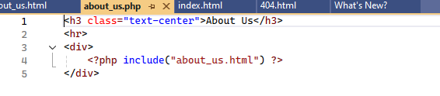

- Appointment (php)
Figure 8
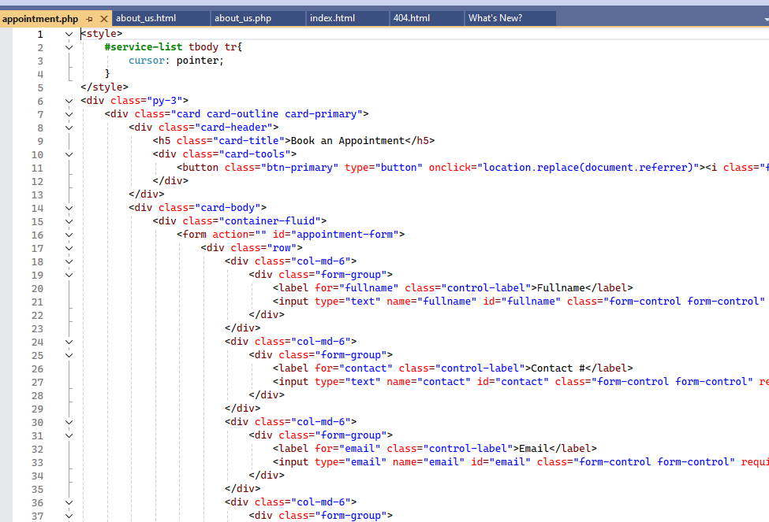
Figure 9
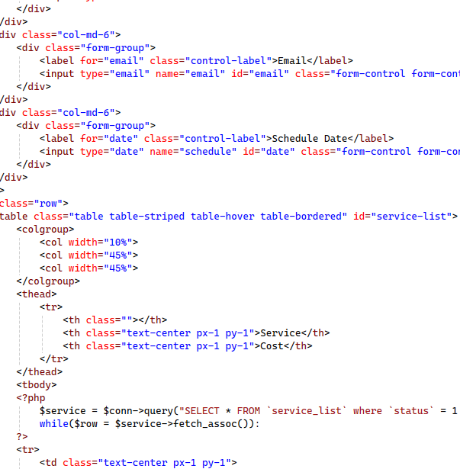

- Config (php)
Figure 10
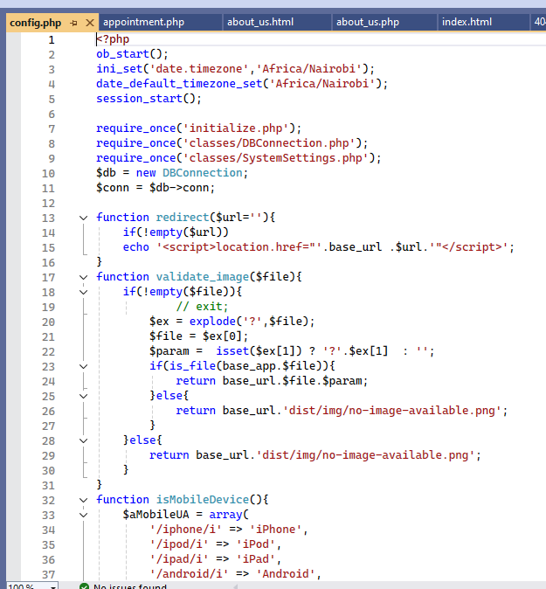
Figure 11
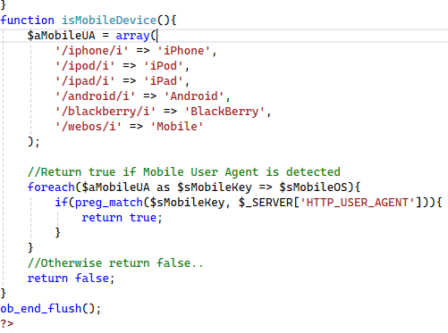

- Contact (php)
Figure 12
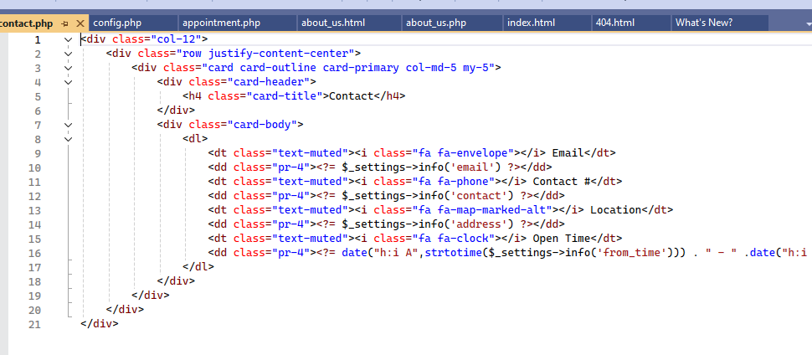

- Home(php)
Figure 13
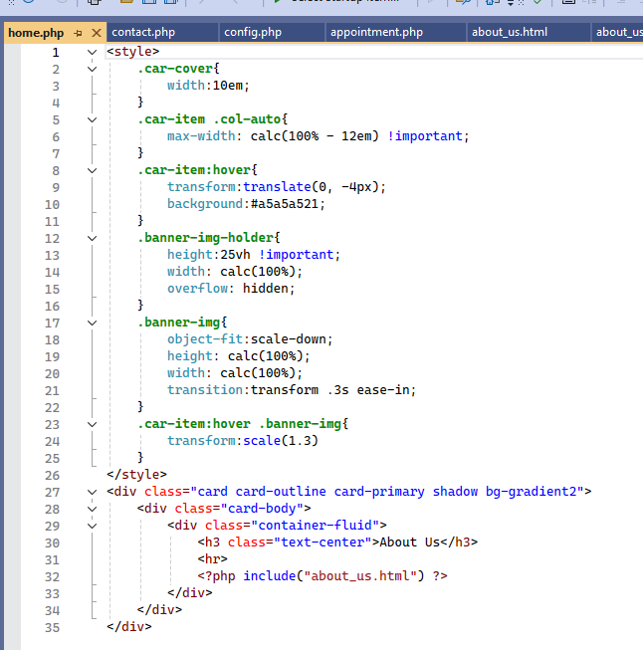

- Initialize(php)
Figure 14
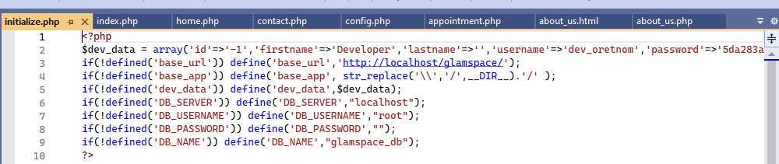

- Message(php)
Figure 15
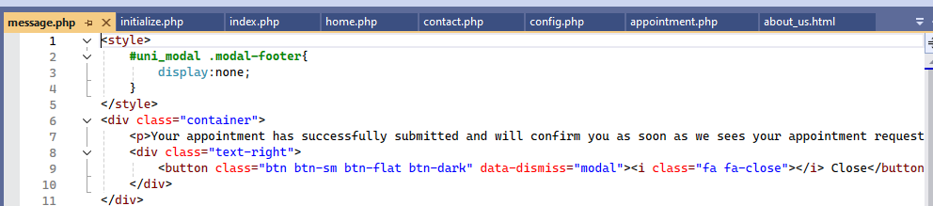

- Services(php)
Figure 16
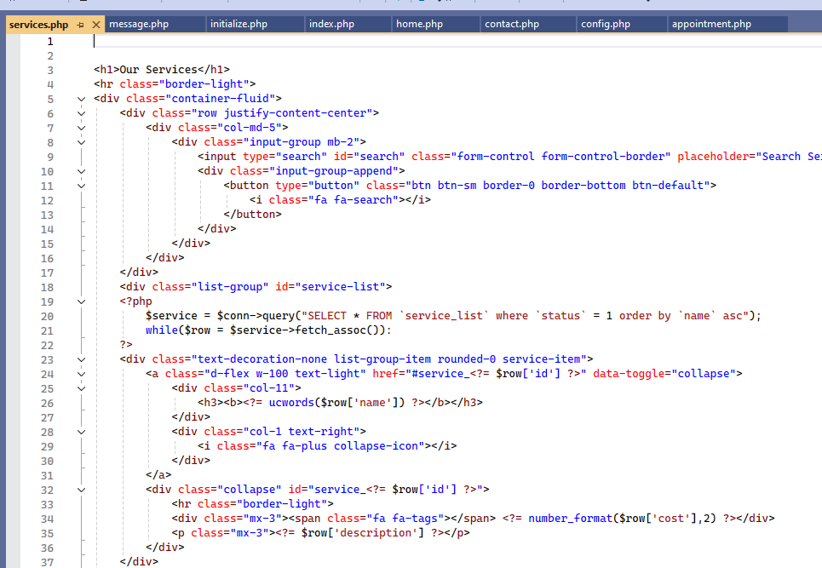
Figure 17
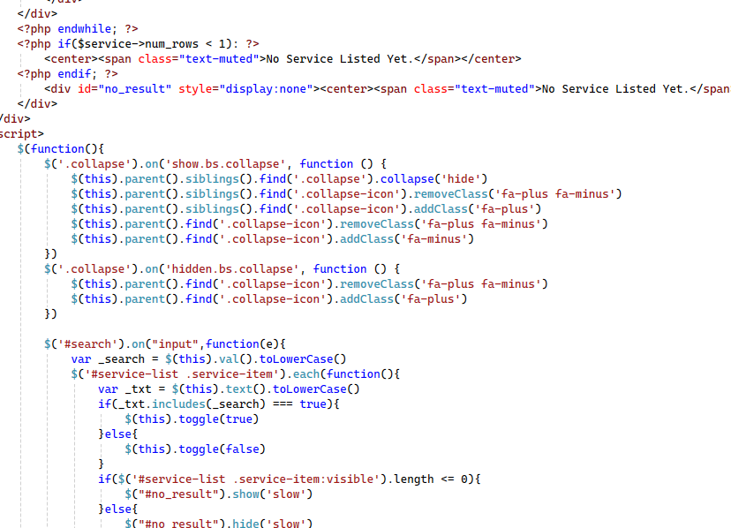
Figure 18
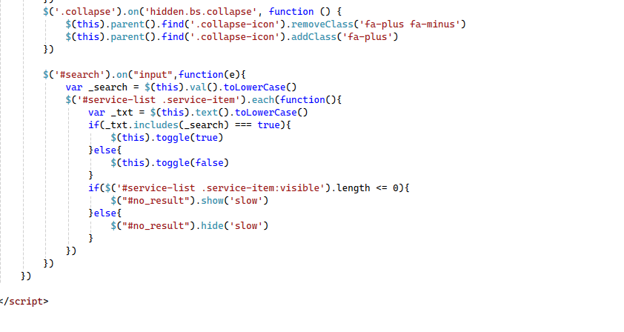

- Folder view (php)
Figure 19
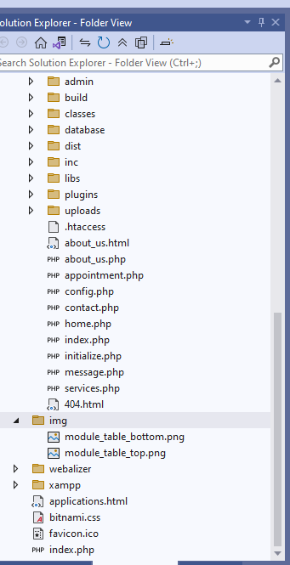

- Database(sql)
Figure 20
Figure 21
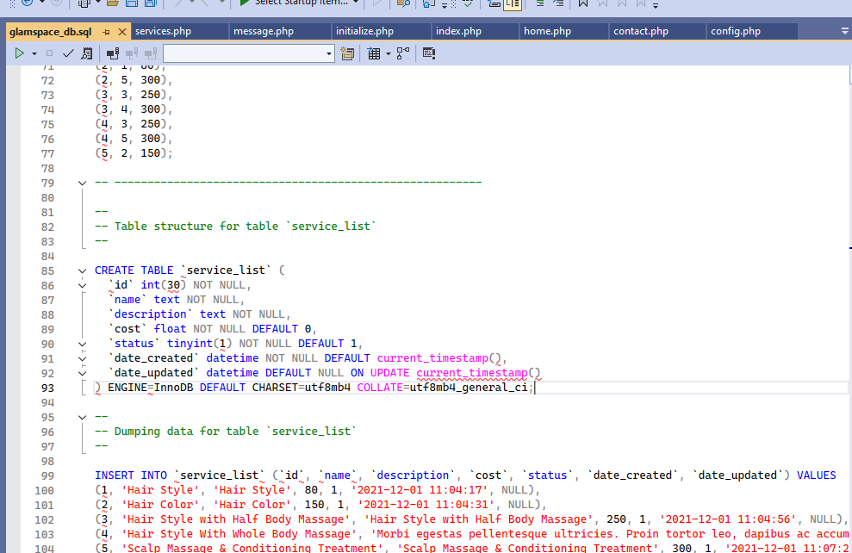

CHAPTER 5: TEST PLAN

5.1 Test Cases
- Test objectives
The primary objectives of testing are:
- To ensure the system meets the functional requirements outlined in the SRS.
- To identify and resolve defects before deployment.
- To validate the system's performance, security, and usability.
- Test Assumptions
- The test environment will mimic the production environment.
- Test data will be prepared and available before testing begins.
- All dependencies (e.g, external mapping services) will be available during testing.
- Data Approach
- Test data will be created to simulate real-world scenarios, including user accounts, salon registrations, and reviews.
- Data will be backed up before testing and restored after each test cycle.
- Level of testing
The following types of testing will be performed
Table 3
Test type | Description | Responsible parties
Unit testing | Testing individual components(e.g, user registration and search functionality) | Development team
Functional testing | Validating the system features against the SRS | QA team
User acceptance testing(UAT) | Ensuring the system meets the user’s requirements and is ready for deployment | End users
Regression testing | Verifying that new changes do not break existing functionality | QA team

- Unit testing
- Features to be tested: User registration, login, salon registration, search functionality, and review submission.
Table 4
Testers name | Department/area | Role
Eric Amadi | Development | Unit tester
Lavender Alela | Development | Unit tester
Sandrine sandy | QA | Test analyst

- Functional testing
- Features to be tested: Location-based search, service and price comparison, review and rating system, and user interface.
Table 5
Tester name | Department/area | Role
Peter Otieno | QA | Functional tester
Pamela Atieno | QA | Functional tester
Christine Anyango | Development | Test analyst

- User acceptance testing
- Features to be tested: End-to-end workflow, including user registration, search, and review submission.
Table 6
Tester name | Department/area | Role
Tanisha Neema | Business | End user
Paul Tyrell | Business | End user
Faith Dennis | QA | UAT coordinator

- Regression testing
- Features to be tested: All existing functionality after implementing new changes.
Table 7
Tester name | Department/area | Role
Billy Alela | QA | Regression tester
Zeddy Zeddy | QA | Regression tester
Ramadhan Baa | Development | Test analyst

- Execution strategy
Entry criteria
The following conditions must be met before testing can begin:
Table 8
Entry criteria | Test team | Technical team | Notes
Test environment is available | Yes | Yes | Ensure the test environment mirrors the production environment
Test data is available | Yes | Yes | Test data should include sample user accounts, salons, and reviewers
The code has emerged successfully | Yes | Yes | All code changes must be reviewed and approved before merging
Development has completed unit testing | Yes | Yes | Unit test results must show a 100% pass rate for critical modules
Test scripts are completed and approved | Yes | Yes | Test scripts must be reviewed and signed off by the QA lead
Exit criteria
Table 9
Exit criteria | Test team | Technical team | Notes
100% test executed | Yes | Yes | All cases must be executed, including edge cases
90% pass rate of test scripts | Yes | Yes | A 90% pass rate is acceptable, but critical defects must be resolved
No open critical or high-severity defects | Yes | Yes | Critical and high-severity defects must be resolved or deferred with approval
All remaining defects are either cancelled or documented as change requested for future release | Yes | Yes | Any defects that are resolved must be formally documented as changes requested and scheduled for future updates. Ensure proper justification and approval for deferred defects
All expected and actual results are captured and documented with the test scripts | Yes | Yes | Ensure that all test scripts include detailed documentation of expected results and actual results. This documentation is critical for audit purposes in the future
All test metrics collected based on reports from the daily and weekly status reports | Yes | Yes | Collect and analyze test metrics (e.g., pass/fail rates, defect counts, test coverage) from daily and weekly status reports. Use these metrics to assess the overall quality and readiness of the system.
All defects are logged in the defects tracer/spreadsheet | Yes | Yes | All defects must be logged in a centralized defect tracker or spreadsheet with detailed information (e.g, severity, steps to reproduce, expected vs actual results). Ensure that no defects are missed.
Test environment cleanup completed | Yes | Yes | The test environment must be reset to its original state, and all test data must be backed up or archived. This ensures the environment is ready for future testing cycles or deployments

.

5.2 Defect Tracking
Critical defects resolved: 100%
- Defect Management: Defects will be logged in a Defect Tracker and categorized by severity:
Table 10
severity | impact
1(critical) | Functionality is blocked, and no testing can proceed.
2(high) | Functionality is not usable, but testing can proceed with a workaround.
3(medium) | Functionality issues with a workaround available.
4(low) | Cosmetic errors are unclear with minimal impact

CHAPTER 6: IMPLEMENTATION PLAN

6.1 Major tasks
The following are the major tasks required for the implementation of the Glamspace system:
- Environment Setup:
  - Set up the development, testing, and production environments.
  - Install necessary software (Visual Studio, Xammp, web browsers).
  - Configure security settings and access controls.
- Database Deployment:
  - Create and populate the Glamspace DB with initial data, including user accounts, salon information, and reviews.
  - Ensure data integrity and security.
- Frontend Development:
  - Develop the user interface using HTML, CSS, and JavaScript.
  - Implement responsive design for mobile and desktop compatibility.
- Backend Development:
  - Developed the backend logic using php and My SQL
  - Implement jQuery for dynamic content loading and interactivity.
- Core Functionality Deployment:
  - Deploy the user registration, login, and profile management modules.
  - Deploy the salon search and comparison functionality.
  - Deploy the review and rating system.
- User Acceptance Testing (UAT):
  - Conduct end-to-end testing with end users to validate the system’s functionality.
  - Address any issues or bugs identified during UAT.
- System Integration:
  - Integrate the system with external mapping services (e.g., Google Maps) for location-based search.
  - Ensure seamless communication between the system and external services.
- Training and Documentation:
  - Provide training sessions for end users, salon owners, and administrators.
  - Prepare user manuals, admin guides, and online help documentation.
- Final Deployment:
  - Deploy the system to the production environment.
  - Monitor system performance and address any post-deployment issues.
6.2 Implementation schedule
The implementation schedule is as follows:
Table 11
Task | Start date | End date | Responsible party
Environmental setup | 15/03/2025 | 15/03/2025 | Development team
Database deployment | 15/03/2025 | 16/03/2025 | Database Administrator
Frontend development | 16/03/2025 | 17/03/2025 | Frontend team
Backend development | 17/03/2025 | 18/03/2025 | Backend team
Core functionality deployment | 18/03/2025 | 19/03/2025 | Development team
User acceptance testing | 20/03/2025 | 20/03/2025 | QA team
System Integration | 21/03/2025 | 21/03/2025 | Development team
Training and documentation | 22/03/2025 | 22/03/2025 | Project manager
Final deployment | 23/03/2025 | 24/03/2025 | Development team

CHAPTER 7: USER GUIDE

7.1 PROCESS OVERVIEW
- Register/Login: Create an account or log in to access the system.
- Search: Find salons/barbershops by location, services, or ratings.
- Compare: View and compare services and prices.
- Book appointment: book appointment according to your choice
- Review: Leave feedback for salons/barbershops.
- Manage Profile: Update user or salon information.
- GETTING STARTED
- REGISTRATION
Steps:
- Click "Register" on the homepage.
- Fill in your details (name, email, and password).
- Click "Submit".
- Verify your email via the confirmation link sent to your inbox.
Note: Salon and barbershop owners must select "Register as Salon" and provide business details (name, location, services).
- LOGIN
Steps:
- Click "Login" on the homepage.
- Enter your email and password
- Click “submit”
Figure 22
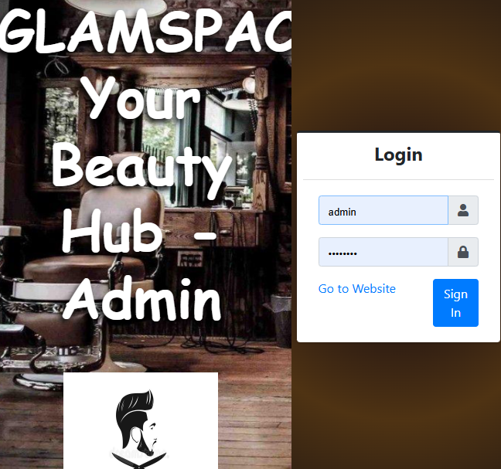
- USING GLAMSPACE
- Searching for salons
Steps:
1. Type your city or any available service, e.g., haircut, on the homepage.
2. Let filters (value of the service, reviews) narrow your results.
3. Choose a particular salon to get more information about that salon (services, working time, phone number).
- Comparing services and prices
Steps:
1. Search for the service you need, such as "manicure."
2. Browse the list of salons that offer this service.
3. Compare the costs and look at the ratings of each salon to help you decide

Figure 23
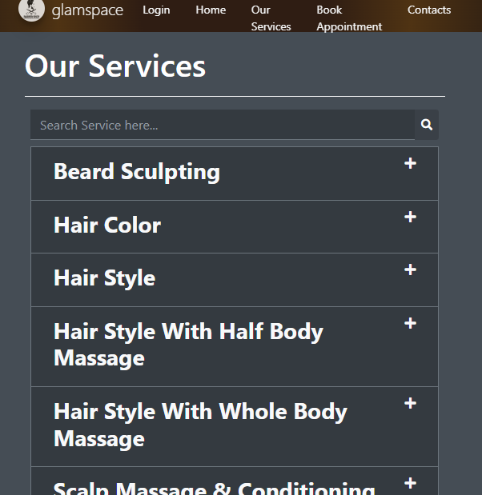
- BOOKING SERVICES
Steps:
- Choose the service you want.
- Choose the location of your choice
- Book a suitable salon/barbershop
Figure 24
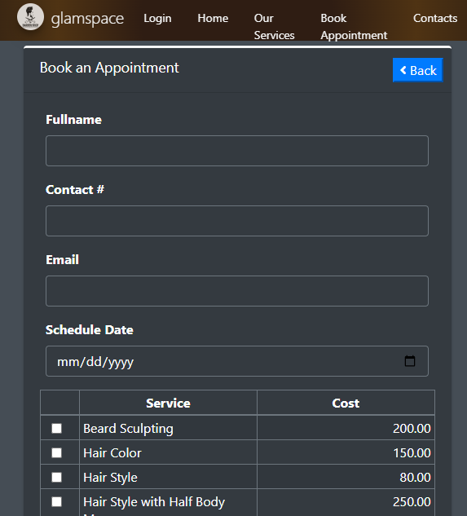

- LEAVING REVIEWS
Steps:
- Navigate to a salon’s details page.
- Click "Leave a Review".
- Rate the salon (1–5 stars) and write your feedback.
- Click "Submit".
Note: Reviews are subject to moderation for inappropriate content.
- MANAGING YOUR PROFILE

For Users:
- Edit Profile: Update your name, email, or password.
- View History: Track past searches and reviews.

For Salon Owners:
- Update Salon Info: Modify services, prices, or operating hours.
- Respond to Reviews: Address customer feedback.

REFERENCES
- Statista Research Department. (2024). Beauty & personal care market - Statistics & facts. Statista. Retrieved from https://www.statista.com/topics/4503/beauty-and-personal-care-market/
- IBISWorld. (2023). Hair & nail salons in the US - Market size 2005–2024. Industry Report 81211. Retrieved from https://www.ibisworld.com/industry-statistics/market-size/hair-nail-salons-united-states/
- Johnson, M. A., & Smith, K. B. (2023). Location-based service applications in the beauty industry: A systematic review. Journal of Information Systems, 45(2), 112-128.
- Thompson, R., & Wilson, J. (2022). Development of a salon-finder system using Visual Basic.

APPENDICES

Appendix 1: ER Diagram

Figure 25
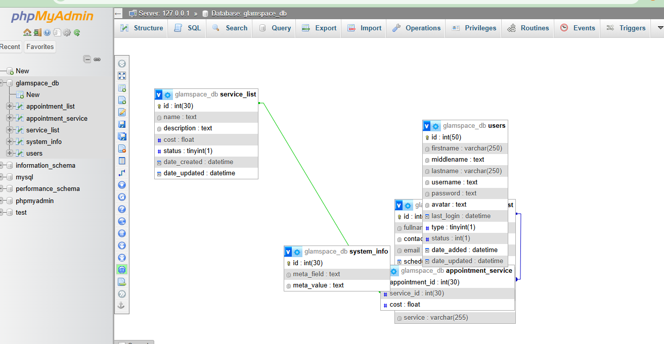

Appendix 2: Sample Test Data
- Dashboard
Figure 26
- Service list
Figure 27
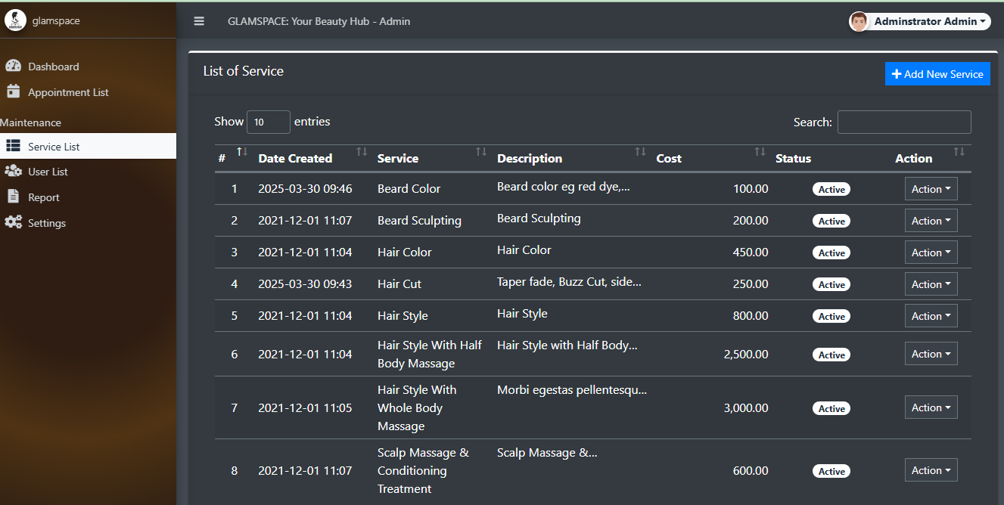
- List of system users
Figure 28
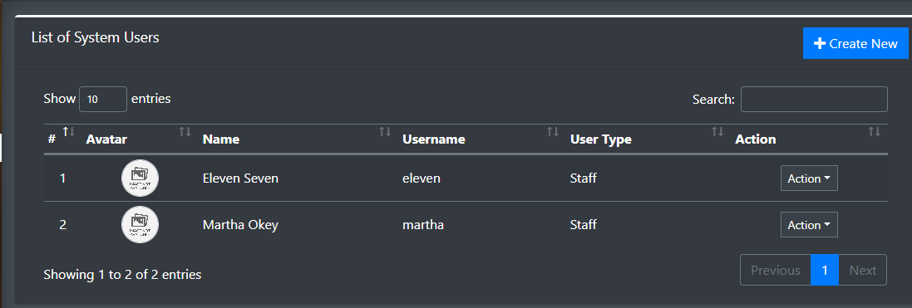
- Reports
Figure 29
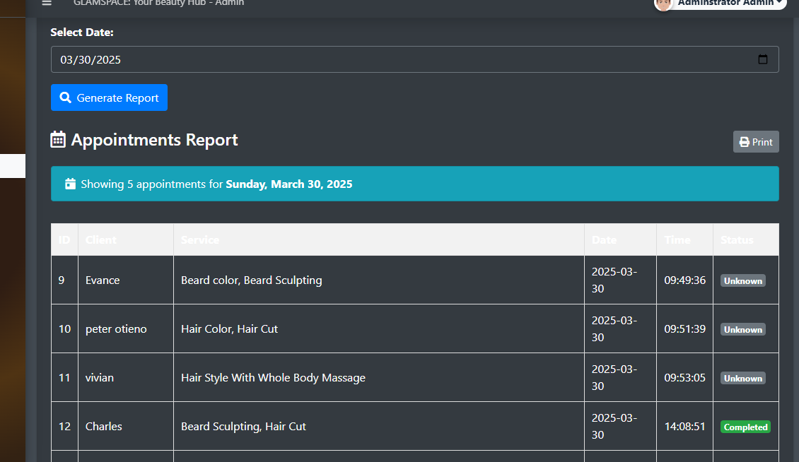
- Appointment list
Figure 30
